SUPPLEMENTARY MATERIAL
“Lipid droplets disrupt mechanosensing in human hepatocytes”
LiKang Chin, Neil D. Theise, Abigail E. Loneker, Paul A. Janmey, Rebecca G. Wells

Sample No. | Storage modulus G’ (Pa) | % Sirius red | % ORO | sGAG (ng/mg wet wt) | HA (ng/mg wet wt) | % cells nuclear YAP
Intermediate/Advanced Cirrhosis, Non-NAFLD
1 | 1130 | 49.3 | 12.0 | - | - | 86.2
2 | 1019 | 16.0 | - | 539.3 | 6.29 | -
3 | 734 | 34.8 | 5.41 | 144 | 11 | 58.9
4 | 1262 | 58.0 | - | 647 | 10.8 | -
5 | 1425 | 32.7 | - | - | - | -
6 | 1126 | 22.9 | 2.60 | 13.1 | 7.82 | 68.7
7 | 1104 | 26.3 | 10.2 | 382 | 12.2 | 53.0
8 | 939 | 34.2 | - | 505 | 122 | -
9 | 1259 | 32.4 | - | 464.9 | 10.52 | -
10 | 836 | 10.5 | - | 363 | 52.9 | -
11 | 1215 | 19.3 | - | 285.8 | 27.85 | -
12 | 717 | 21.6 | - | 386.2 | 15.7 | -
13 | 600 | 31.6 | - | 475.1 | 42.9 | -
14 | 995 | 15.8 | 8.18 | 706 | 30.8 | 56.7
15 | 1080 | 29.4 | - | 465.8 | 17.1 | -
16 | 1034 | 33.2 | - | 792.8 | 83.3 | -
17 | 917 | 19.0 | - | 358.8 | 4.77 | -
18 | 1102 | 30.8 | - | 728.9 | 46.87 | -
19 | 697 | 27.4 | - | 420.8 | 11.83 | -
20 | 1119 | 28.3 | - | 549 | 14.11 | -
21 | 542 | 16.2 | - | - | - | -
22 | 630 | 23.0 | - | - | - | -
23 | 861 | 15.9 | - | - | - | -
24 | 824 | 8.57 | - | - | - | -
25 | 589 | 13.7 | - | 315.6 | 2.97 | -
26 | 571 | 14.7 | - | 422.5 | 2.19 | -
27 | 1232 | 40.8 | - | - | - | -
Intermediate/Advanced Cirrhosis, NAFLD
28 | 508 | 23.8 | - | - | - | -
29 | 511 | 16.3 | - | 463 | 127 | -
30 | 869 | 40.7 | 24.2 | 533 | 26.5 | -
31 | 1103 | 20.3 | 27.3 | 456.4 | 13.81 | 73.0 (small)  100 (large)
32 | 796 | 57.1 | 8.30 | 541.5 | 20.51 | -
33 | 668 | 9.31 | 35.9 | - | - | 65.2 (small),  100 (large)
34 | 1171 | 25.6 | 13.7 | - | - | -
35 | 918 | 14.2 | - | - | - | 53.0 (small)  91.7 (large)
36 | 1834 | 22.8 | 21.8 | 454.3 | 81.5 | -
37 | - | - | - | - | - | 66.7 (small)  89.4 (large)
38 | - | - | - | - | - | 100 (large)

Supplemental Table S1. Storage modulus G’, % Sirius red, % ORO, sGAG content, HA content, and % cells with nuclear YAP data for cirrhotic human livers.

Supplemental Fig. S1. NAFLD cirrhotic livers have the same amounts of sGAG and HA as non-NAFLD cirrhotic livers. A) sGAG and B) HA quantification for cirrhotic livers, with and without NAFLD. Scatter plots of G’ versus C) sGAG showing no correlation (power law fit, p=0.35) and D) HA showing no correlation (power law fit, p=0.18). Error bars are SEM. n=20 non-NAFLD, 5 NAFLD.

Supplemental Fig. S2. Fatty acid treatment does not cause cytotoxicity or induce senescence or apoptosis. PHH seeded on collagen-coated 96-well plates were treated with 400 µM oleate or linoleate for 48 hours and A) assayed for LDH cytotoxicity, B) stained for β-galactosidase to assess cell senescence (representative brightfield images), and C) stained for caspase3 for apoptosis (representative confocal images). D) Caspase3 mean intensity was quantified. Staining of fatty acid-treated cells on PAA gels as opposed to tissue culture plastic similarly showed low intensity caspase3 staining similar to tissue culture plastic (data not shown). Scale bars, 50 µm. ****p≤0.0001. For A, n=3 independent experiments each with triplicate samples. For B, positive control treated with 300 µM H₂O₂ for 8 d, n=2 independent experiments. For C and D, positive control treated with 5 µM staurosporine (STS) for 20 hours, n=18-23 total cells from 2 independent experiments. Error bars are ± SEM.
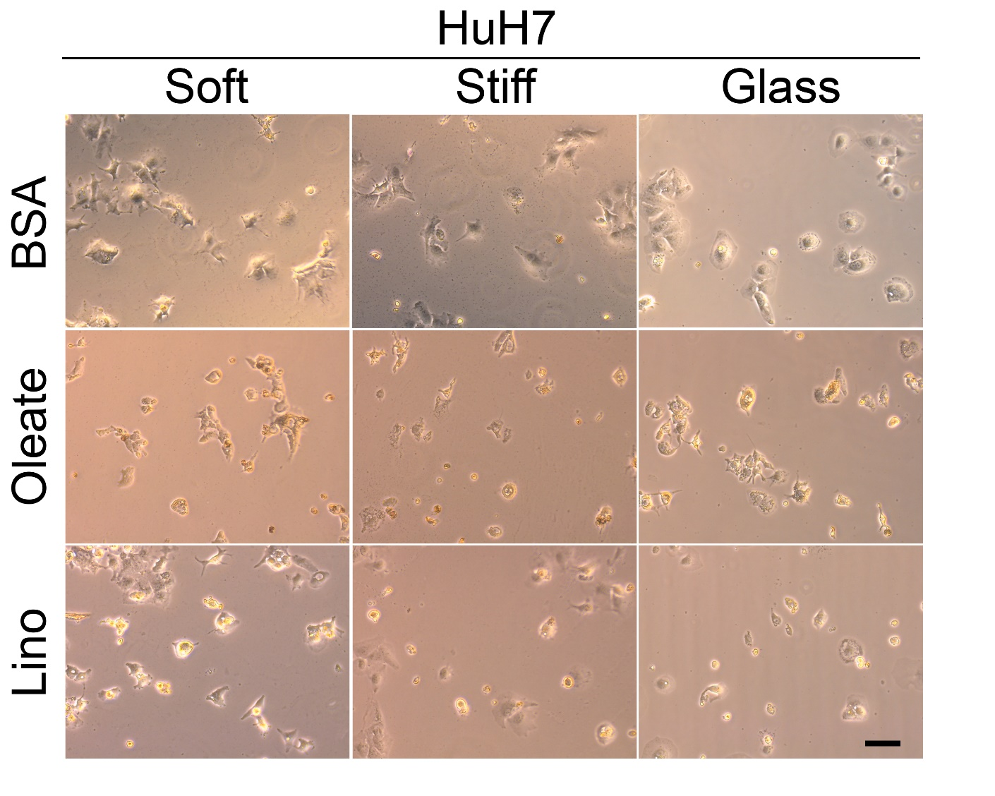
Supplemental Fig. S3. Stiffness-dependent cell spreading decreases in fatty acid-loaded HuH7 cells. Representative live-cell brightfield images of HuH7 cells seeded on 500 Pa (soft) or 10k Pa (stiff) PAA-collagen gels, or glass; treated with 400 µM oleate or linoleate for 48 h. Quantification of cell area, circularity, and solidity are shown in Fig. 4D, E, F. Scale bar, 50 µm. n=60 total cells per condition from three independent experiments.

Supplemental Fig. S4. Fatty acid treatment disrupts stress fibers and focal adhesions in PHH and HuH7. Representative confocal images of A) PHH and B and C) HuH7 cells seeded on 500 Pa (soft), 10k Pa (stiff) PAA-collagen gels, or glass (collagen-coated for PHH), treated with 400 µM oleate or linoleate for 48 h, and stained for vinculin (green), actin (red), and nuclei (blue). Note that panel A is the same as that shown in Figure 5A, but here, imaging settings are the same for all. For Huh7, intensity was optimized for each image to best visualize the vinculin and actin staining (B); vinculin staining was quantified from the original images all taken at the same settings as shown in C. D) The percentage of HuH7 cells that exhibited stress fibers, E) vinculin patches, as defined by punctate staining located at the end of stress fibers, and F) total cell area of vinculin staining (not quantified for oleate-treated cells due to non-specific staining of the lipid droplets). Scale bar, 50 µm. *p≤0.05, ** p≤0.01, ***p≤0.001, ****p≤0.0001, #0.05<p≤0.100. Percent stress fibers or vinculin, n=3 independent experiments. Vinculin area, n=19-35 total cells per condition from three independent experiments. Error bars are ± SEM.

Supplemental Fig. S5. Cells with small lipid droplets show no change in YAP nuclear translocation or mean intensity in Huh7 cells. A) Representative confocal images of HuH7 cells seeded on 500 Pa (soft) or 10k Pa (stiff) PAA-collagen gels or glass, treated with 400 µM oleate or linoleate for 48 h, and stained for YAP (green) and nuclei (blue). B) Nuclear to cytosolic YAP ratio was quantified. C) YAP mean intensity over the entire cell was measured. YAP mean intensity increased on glass, but fatty acid treatment had no effect. Scale bar, 50 µm. *p≤0.05, ***p≤0.001, ****p≤0.0001, #0.05<p≤0.100. n=20-38 total cells per condition from two independent experiments. Error bars are ± SEM.

Supplemental Fig. S6. Insulin treatment does not increase nuclear YAP in cells on glass. A) Representative confocal images of PHH seeded on 500 Pa (soft) or 10k Pa (stiff) PAA-collagen gels or collagen-coated glass treated with or without 100 nM insulin. Cells were stained for lipid (green), YAP (red), and nuclei (blue). Intensity was optimized for each stiffness to best visualize YAP staining (A). B) The nuclear to cytosolic YAP ratio was quantified, and cells treated with insulin had significantly less, but not more, nuclear YAP than BSA controls when seeded on glass. Scale bar, 50 µm. *p≤0.05, ***p≤0.001, ****p≤0.0001. n=34-49 total cells per condition from four independent experiments using cells from one donor. Error bars are ± SEM.

